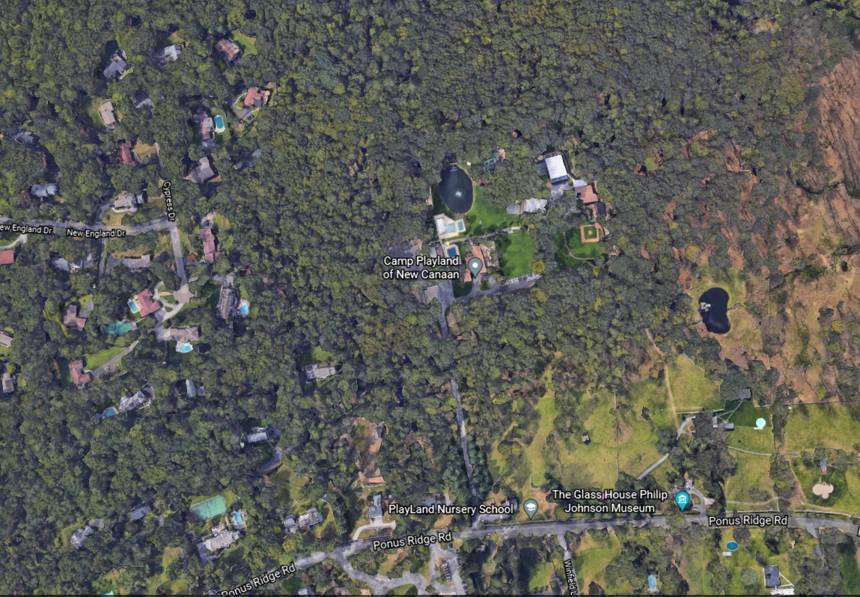
ZBA APPLICATION #037-21
800 Ponus Ridge Road

