Caroline Simmons
Mayor

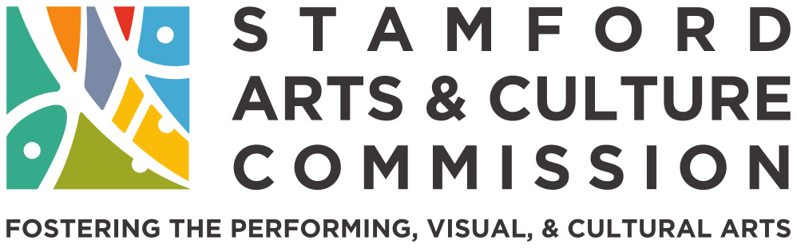
Aaron Miller
Program Manager of Arts, Culture, & Tourism
Lynne Colatrella
Chair
Valerie Cooper
Vice-Chair Marti Etter Secretary

Members Dennis Collins Lisa Cuscuna Michael Moran Lou Ursone

Regular Meeting Notice

Date: Wednesday, September 21st, 2022
Time: 9:00 AM
Place: Democratic Caucus Room, Government Center 888 Washington Blvd

Agenda

- Call to Order & Roll Call
- Reading and Approval of Minutes
  - Approval of Minutes July 2022
- Staff Report – Aaron
- Chair Report
  - Grant Application
  - BLM Mural
  - Commissioners needed
- Committee Reports
  - Finance – Lynne
  - Convening – Lisa & Marti
  - Programming – Lou & Mike
  - Diversity – Val & Dennis
- New Business
  - CT Cultural Fund Info Session
- Adjournment

888 WASHINGTON BOULEVARD, 10th FLOOR, STAMFORD, CT 06901 TELEPHONE: (203) 977-1193 • EMAIL: AMILLER1@STAMFORDCT.GOV

